Zachary Ballard
Panem Districts
The map and key shows where the districts are in the nation of Panem. So the Capitol is by the rocky mountain’s which says in the book while they are on the train. District one makes luxury items for the capitol so it would be fairly close to the capitol. District two makes weapons and tools, so it would be in the desert somewhere. District three is electricity and engineering, so it would be near the Hoover dam. District four is water and fishing so it would be by fresh water lakes (the great lakes). District five is power so it would have a direct line to the Capitol. District six is transportation so they would need to by water and land to test their products. District 7 is lumber so it would be in a forest so it would be in the red wood forest. District eight makes textiles, fashion, decoration, clothing furniture etc. So it would be by district seven where all of the lumber is processed to make the furniture, decorations etc . District nine is wheat so it would be in the great planes to farm it. District ten is ranching and animals so it is near where many farms are. District eleven is agriculture so it would be where many trees can grow and plants can flourish so in a moist area in Virginia. District twelve is somewhere near the Aplachian mountain’s where you can find a lot of coal which district twelve specializes in. District thirteen is nuclear weapons and graphite. So it would have to be the farthest away to test nuclear weapons and in the mountains to mine graphite.
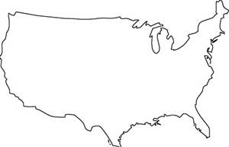

Capitol District 8
District 1 District 9
District 2 District 10
District 3 District 11
District 4 District 12
District 5 District 13
District 6
District 7

